$(¬Stench\left(x\right) ∨Adjacent(x, C))∧(¬Stench\left(x\right)∨At(Wumpus,C))$

$∀x[Likes\left(x, Apples\right)⇒Plays(x,Chess)]$

$∀x[Likes\left(x, Oranges\right)⇒Plays(x,Go)]$

$∀x[¬((Likes\left(x, Apples\right)∨Likes\left(x,Oranges\right))⇒(Likes\left(x, Apples\right)∧Likes\left(x,Oranges\right))]$

$Likes\left(John, Apples\right)$

$∀y[Likes\left(John,y\right)⇒¬Likes(Mary,y)]$

1. $¬Likes\left(x, Apples\right)∨Plays(x,Chess)$– C1
2. $¬Likes\left(x, Oranges\right)∨Plays(x,Go)$– C2
3. $(Likes\left(x, Apples\right)∨Likes\left(x,Oranges\right))∧(¬Likes\left(x, Apples\right)∧¬Likes\left(x,Oranges\right))$– C3 ∧ C4
4. $Likes\left(John, Apples\right)$– C5
5. $¬Likes\left(John,y\right)∨¬Likes(Mary,y)$– C6

|  |  |
| --- | --- |
| $$¬Likes\left(x, Oranges\right)∨Plays\left(x,Go\right)-C2$$ | $$¬Plays(Mary, Go)$$ |
|  |  |
| $$Likes\left(x, Apples\right)∨Likes\left(x,Oranges\right)-C3$$ | $$¬Likes\left(Mary, Oranges\right)$$ |
|  |  |
| $$¬Likes\left(John,y\right)∨¬Likes\left(Mary,y\right)-C6$$ | $$Likes\left(Mary, Apples\right)$$ |
|  |  |
| $$Likes\left(John, Apples\right)-C5$$ | $$¬Likes\left(John,Apples\right)$$ |
|  |  |
|  | Refutation |

Sorry, this doesn’t look really nice but I have no idea how to make it better ☹

Input:

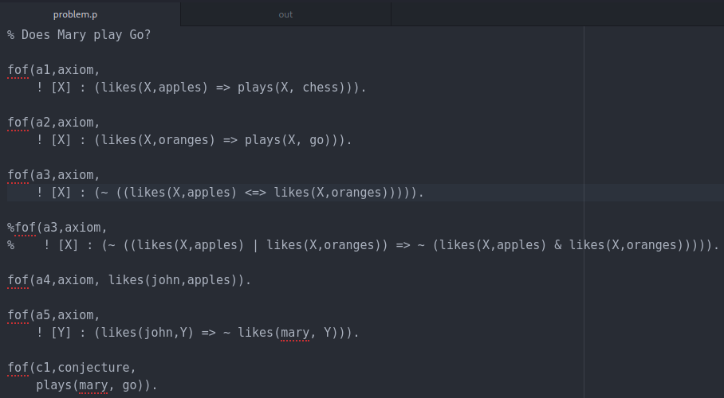

Output:

